Crossroads International Church Dr. Rick Griffith
16 Feb 2014 Series on Revelation Message 11 of 20
NLT 40 Minutes
The Christ of Balance
Title
Revelation 6–7

Topic: Grace
Subject: What’s the right view of Jesus in terms of justice and grace?
Complement: Christ balances his judgment with his grace.
Purpose: The listeners will see that Christ has the right to judge them but prefers to save them!
Song: Only By Grace

Introduction

Interest: Life is quite perplexing today, so we all appreciate balance in life.
Balance
Signs

We see the need for a work and family, so this poster reads…
Work 12 hours

We see it’s more complex than this.
Wheel

Are you balanced? We all see the need for balance in terms of our desire for justice (we all cry for justice!), but also we see the need for grace.
Justice & grace
Jesus Balanced?
Are you balanced?

Need: What’s your view of Jesus? Is he balanced?

Is Jesus an angry hard-liner who’s heavy on justice? If so, he wouldn’t offer grace.
Justice!
Grace
Angry Jesus

Is Jesus simply a flower sniffer? If so, he wouldn’t give justice.
Flower Sniffer

Subject: What’s the right view of Jesus in terms of justice and grace?

Background: Revelation 4–5 shows us that only Christ is worthy to break the seals. But why should he break these seals?
Rev 1-5
(16 slides)

Preview: Today we will see Jesus with the perfect balance as both Judge and Savior.
Jesus is balanced

Text: Revelation 6 shows him as Judge while Revelation 7 shows him as Savior.

(Let’s first see the quality of Christ where he will not let sin continue forever since…)

I. Christ will judge the world (Rev. 6).
MI
[Jesus will open the seals to reveal His sovereignty to punish those rejecting him.]
Horsemen
[Christ’s authority is depicted as releasing four horsemen in verses 1-8.]

(6:1-2) Christ will open the first seal (white horse) that allows the Antichrist to conquer the world to show Christ's sovereignty over him.
Seal

Many believe this horseman is Jesus Christ due to similarities with Christ at the Second Advent (Rev. 19:11-16) and the white color of the horse (1:14; 2:17; 3:4, 5, 18).

However, other factors reveal this to be the future Antichrist:
Antichrist

The Lamb breaks the seal to enact this judgment, so the Lamb and the rider must be different persons.
• Not Lamb

White does not always depict what is holy (Matt. 23:27; Acts 23:3) and thus may indicate that the rider only deceptively seeks to appear holy (cf. Matt. 24:5; crowns, 12:3; victories, 11:7; 13:7).
• Differs from 19:11f
• “White” deceptive

The only thing common to the riders of 6:2 and 19:11-16 is the white color. They differ in many respects, including their:
Different Horsemen

purposes (conquest vs. righteous retribution)
• Purposes

equipment (bow vs. sword)
• Equipt

names (anonymous vs. “Faithful and True”)
• Names

fellow riders (none vs. armies of heaven)
• Riders
• Time
• Context

time (beginning vs. end of the tribulation), and

context (association with other evil riders vs. conquering the Antichrist).

crown: “The word for crown in Revelation 6:2 is stephanos, which means “the victor’s crown.” The crown that Jesus Christ wears is diadema, “the kingly crown” (Rev. 19:12). Antichrist could never wear the diadem, because it belongs only to the Son of God” (Wiersbe).
Wiersbe quote
• Crown

How will the Antichrist rule the world for seven years?
Timeline

He will make a covenant with Israel (cf. Dan. 9:27)

He will control the world government (cf. Rev. 13).

(6:3-4) The second seal (red horse) brings war to depict how Antichrist controls the world as political leader (cf. Matt. 24:6-7a).
Seal 2

(6:5-6) The third seal (black horse) allows Antichrist to use famine to control commodity prices to show his global economic control (cf. Matt. 24:7b).
Seal 3

(6:7-8) The fourth seal (pale horse) affirms that death will come to over one billion people by war, famine, plague, or roaming wild beasts (cf. Matt. 24:9).
Horses
Mt 24
Horses
Seal 4

(6:9-11) The fifth seal depicts God's reassurance of martyrs in heaven that He alone is sovereign and they should trust in His plan.

(6:12-17) The sixth seal reveals that men will fear a glimpse of Sovereign God more than an earthquake leveling mountains and the opening of the sky (cf. Matt. 24:7c)!
Seal 6
Seal 5
MPI
(I noted earlier that Christ has the perfect balance in his character. If Jesus only judged unbelievers, the picture of him would be incomplete. The next chapter shows also that…)

II. Christ will save the believers (Rev. 7).
MPII
[Jesus will be merciful even in judgment by saving believing Jews and Gentiles from every nation.]
[This parenthesis between the sixth and seventh seals gives hope that Christ will show his grace to people from every ethnic group.]
Chronology (parenthesis)

(7:1-8) The sealing of 144,000 Jews (12,000 from each tribe) will show God's mercy on Israel even during the Tribulation.
144k

Many claim that these 144,000 are the church.

However, the 144,000 are Jews who will trust Christ since:
144k miracle

The text could not be clearer that they are Jews in that it shows exactly which tribe each comes from.

“Nowhere else in the Bible do a dozen references to the 12 tribes mean the church.”
Future for Israel?

Many more than 144,000 Christians are sealed to bring forth the message salvation during the church age, so why would it be so incredible that 144,000 of the present 15 million Jews in the world would also have a similar task in the future?
God’s plan for Israel
Chart

This group is contrasted with Gentile believers in the next section.

This is not the total number of Jews saved in the Tribulation but only those specifically "sealed" (7:3-4).
Israel a pain…

Romans 11:26 teaches us that “all Israel will be saved” at this time. Jews will finally place their faith in Jesus Christ as Messiah after centuries of rejecting him!
Rom 11:26

Isaiah especially highlights Israel’s spiritual restoration throughout his prophecy (see references on p. 371).

What is the significance of the sealing of these Jews?

“While we are not told explicitly in Scripture that the 144,000 Jews are God’s special witnesses, and that the Gentile host is saved through their ministry, this appears to be a logical deduction; otherwise, why are they associated in this chapter?

“The parallel with Matthew 24:14 also indicates that the 144,000 will witness for the Lord during the Tribulation.”
Matt. 24:14

(7:9-17) The salvation of Gentiles from every nation indicates God’s merciful fulfillment of the Great Commission during the Tribulation.
Rewards

People will be saved from every tribe, nation, language and people (7:9).
7:9

The elders will praise God for his mercy (7:11).
7:11
Balance Beam
(So what’s the point of these two chapters? Simply put…)

Conclusion

Christ balances his judgment with his grace (MI).
MI

How do we see these qualities in perfect balance (MPs)?

Christ will judge the world (Rev. 6).
MPI

Christ will save the believers (Rev. 7).
MPII

Do you have a defective view of Christ (Application)?
Defective Jesus?

Do you recognize his right to judge his creation—and even you?

Have you responded to his salvation offer?
Jesus Sovereign

Christ is the Ruler of the kings of the earth (1:5)!

Christ has the right to judge you but prefers to save you!
Jesus Preference

Prayer
Black

Preliminary Questions

Verses Questions

Context: What did the author record just prior to this passage?

Purpose: Why is this passage in the Bible?

Background: What historical context helps us understand this passage?

Questions

Tentative Subject/Complement Statements

Text

Possible Illustrations

Text

Possible Applications

Text

The Purposes & Names of the Tribulation

If God is a God of love, why must there be a time of great tribulation on earth?

1. To Judge the Nations: God is a God of justice as well as a God of love. His wrath must be shown to demonstrate Him to be consistent with His balanced character (e.g., Zeph. 1:15; 1 Thess. 1:10; 5:9; Rev. 11:18; 15:1; 16:1).

- This will be a period when God gives those who killed His people the fruits of their sin (Rev. 6:11; cf. Ps. 2:5; Jer. 25:30-32; Zech. 12:3; 2 Thess. 2:12; Rev. 3:10; 6:15).

- God has always judged sin and does so at the present, so this period is not out of line with His actions in the past (Rom. 1:18-20).

2. To Discipline Israel: Israel will need a time of difficulty to turn her heart to the Lord in order to fulfill the prophecies of the nation’s restoration in repentance (Deut. 30:1-3; Isa. 1:25; 4:2-4, etc.; cf. Eschatology notes, 119c point D).

3. To Save Israel: God’s mercy will be shown to Israel by saving her after this time of trouble.

- Jer. 30:7 refers to the “time of Jacob’s trouble” that will lead to national salvation.

- Dan. 11:36-45 shows how God will miraculously save Israel from the attacks of Antichrist.

- Israel’s spiritual restoration is especially highlighted by Isaiah in many texts:
1. Israel cleansed by God’s judgment before the kingdom (1:25; 4:2-4; 29:1-4; 30:26b; 31:6-7)
2. Israel reunited and regathered to the land (11:10-13, 15-16; 43:1, 5; 49:6; 61:4; 65:8-9)
3. Israel victorious over enemies (2:12-21; 11:14; 24:21-23; 41:11-14; 45:14; 61:2; 66:14b)
4. Israel free from oppression (14:3-6; 42:6-7; 49:8-9)
5. Israel believing in Messiah (2:5; 10:20-22; 25:8-9; 26:2; 29:23; 40:9; 45:17, 25; 52:3, 6-7, 9-11; 54:7-10; 62:12)
6. Israel forgiven, redeemed and righteous (1:25-27; 2:3; 4:3-4; 33:24; 44:22-24; 45:25; 48:17; 63:16)
7. Israel blessed and rewarded by Christ (19:25; 40:10; 62:11; 61:8)
8. Israel comforted by Christ (12:1-2; 40:1-2, 11; 49:12; 51:3; 65:18-19; 66:11-13)
9. Israel filled/empowered by Holy Spirit as never before (32:15; 44:3; 59:21)

4. To Establish the Millennial Kingdom: The Tribulation will end with the elimination of the kingdoms of this world so they can be replaced with Christ’s kingdom (Dan. 7:17-18; cf. Rev. 17-18 removes Babylon before Rev. 19-20 sets up Christ’s reign).

The various names for this period of time reveal some of God’s purposes:

• “Day” or “Day of the LORD”—Isa. 30:23-25; 34:1-8; 35:1-10; Joel 2:28-32; 3:1-21; Zeph. 3:8, 16-20; Zech. 14:1-21)

• “Tribulation”—Deut. 4:30; Matt. 24:9, 21, 29; Rev. 7:14

• “Time of Jacob’s trouble”—Jer. 30:7

• “Wrath of God”—Zeph. 1:15; 1 Thess. 1:10; 5:9; Rev. 11:18; 15:1; 16:1

• “Seven”—Dan. 9:27

(6:1–8:5) Christ opens seven seals to reveal His sovereignty to judge the world and save many during the first half of the seven-year tribulation.

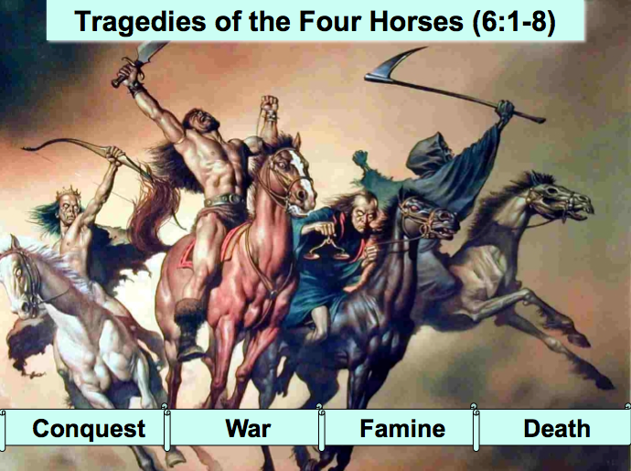

(6:1-2) Christ opens the first seal (white horse) that allows the Antichrist to conquer the world through his world government and covenant with Israel (cf. Dan. 9:27) to show Christ's sovereignty over him.

Many believe this horseman is Jesus Christ due to similarities with Christ at the Second Advent (Rev. 19:11-16) and the white color of the horse (1:14; 2:17; 3:4, 5, 18).

However, other factors reveal this to be the future Antichrist:

The Lamb breaks the seal to enact this judgment, so the Lamb and the rider must be different persons.

White does not always depict what is holy (Matt. 23:27; Acts 23:3) and thus may indicate that the rider only deceptively seeks to appear holy (cf. Matt. 24:5; crowns, 12:3; victories, 11:7; 13:7).

The only thing common to the riders of 6:2 and 19:11-16 is the white color. They differ in many respects, including their:

purposes (conquest vs. righteous retribution)

equipment (bow vs. sword)

names (anonymous vs. “Faithful and True”)

fellow riders (none vs. armies of heaven)

time (beginning vs. end of the tribulation), and

context (association with other evil riders vs. conquering the Antichrist).

crown: “The word for crown in Revelation 6:2 is stephanos, which means “the victor’s crown.” The crown that Jesus Christ wears is diadema, “the kingly crown” (Rev. 19:12). Antichrist could never wear the diadem, because it belongs only to the Son of God” (Wiersbe).

(6:3-4) The second seal (red horse) brings war to depict how Antichrist controls the world as political leader (cf. Matt. 24:6-7a).

(6:5-6) The third seal (black horse) allows Antichrist to use famine to control commodity prices to show his global economic control (cf. Matt. 24:7b).

(6:7-8) The fourth seal (pale horse) affirms that death will come to over one billion people by war, famine, plague, or roaming wild beasts (cf. Matt. 24:9).

(6:9-11) The fifth seal depicts God's reassurance of martyrs in heaven that He alone is sovereign and they should trust in His plan.

(6:12-17) The sixth seal reveals that men will fear a glimpse of Sovereign God more than an earthquake leveling mountains and the opening of the sky (cf. Matt. 24:7c)!

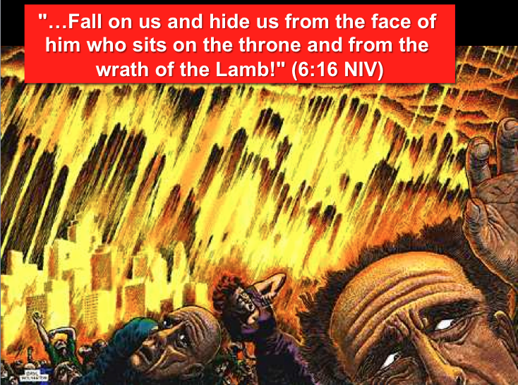

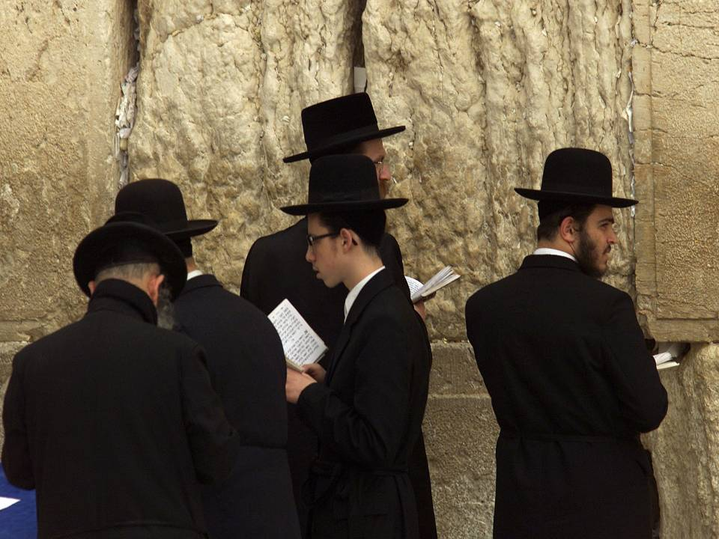

(7:1-17) A parenthesis between the sixth and seventh seals provides hope that God will be merciful even in judgment by saving believing Jews and Gentiles from every nation. (See the chart on “Chronology of Revelation” on page 340 for the concept of various parentheses in the book of Revelation.)

(7:1-8) The sealing of 144,000 Jews composed of 12,000 from each tribe is described to show God's mercy on Israel even during the Tribulation.

Many claim that these 144,000 are the church.

However, the 144,000 are Jews who will trust Christ since:

The text could not be clearer that they are Jews in that it shows exactly which tribe each comes from.

“Nowhere else in the Bible do a dozen references to the 12 tribes mean the church.”

Much more than 144,000 Christians are sealed to bring forth the message salvation during the church age, so why would it be so incredible that 144,000 of the present 15 million Jews in the world would also have a similar task in the future?

This group is contrasted with Gentile believers in the next section.

144,000 | Great Multitude
7:1-8 | 7:9-17
Jews | Gentiles from all nations
Numbered | Cannot be counted
Listed by tribe of Israel | From every nation, tribe, people and language
“seal of God on their foreheads” (7:3-4) | “washed their robes in the blood of the Lamb and made them white” (7:14)
On earth | Standing in heaven

This is not the total number of Jews saved in the Tribulation but only those specifically "sealed" (7:3-4). Romans 11:26 teaches us that “all Israel will be saved” at this time. Jews will finally place their faith in Jesus Christ as Messiah after centuries of rejecting him! Isaiah especially highlights Israel’s spiritual restoration throughout his prophecy (see references on p. 371).

What is the significance of the sealing of these Jews?

“While we are not told explicitly in Scripture that the 144,000 Jews are God’s special witnesses, and that the Gentile host is saved through their ministry, this appears to be a logical deduction; otherwise, why are they associated in this chapter? The parallel with Matthew 24:14 also indicates that the 144,000 will witness for the Lord during the Tribulation.”

Why No Tribe of Dan?

“Much speculation has arisen about why the tribe of Dan is omitted. Joseph and one of his two sons, Manasseh, are listed, but Ephraim, Joseph’s other son, is omitted. Thus if Dan were included, there would have been 13 tribes. According to J.B. Smith, Scripture contains 29 lists of the tribes of Israel in the Old and New Testaments and in no case are more than 12 tribes mentioned (A Revelation of Jesus Christ, p. 130). The tribe omitted was usually Levi, from which the priesthood came. Inasmuch as it is normal to have only 12 and not 13 tribes, the omission of Dan is not significant. Perhaps Dan was omitted here because it was one of the first tribes to go into idolatry (Jud. 18:30; cf. 1 Kings 12:28-29). However, Dan is mentioned in Ezekiel 48:2 in the millennial land distribution.

“The most important fact taught here is that God continues to watch over Israel even in the time of Israel’s great distress. There is no justification whatever for spiritualizing either the number or the names of the tribes in this passage, to make them represent the church.”

(7:9-17) The salvation of Gentiles from every nation indicates God’s merciful fulfillment of the Great Commission during the Tribulation.
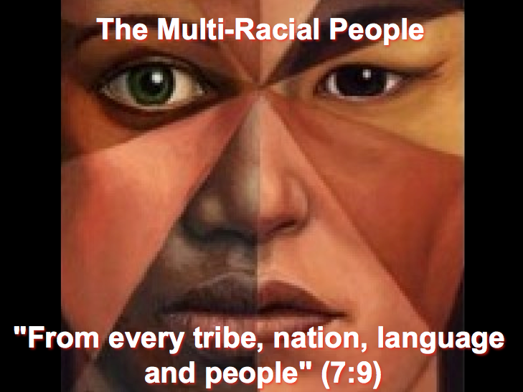

(8:1-5) The seventh seal has no judgment connected with it as it introduces the trumpet judgments in response to the prayer for vindication by the Tribulation martyrs (6:10).
The Christ of Balance
Revelation 6–7

Exegetical Outline (Steps 2-3)

Exegetical Idea: The reason Christ will open the seals will be to reveal His sovereignty to judge the world and to save many during the first half of the seven-year tribulation.

I. The reason Christ will open the seals will be to reveal His sovereignty to judge the world (Rev. 6).

(6:1-2) Christ opens the first seal (white horse) that allows the Antichrist to conquer the world through his world government and covenant with Israel (cf. Dan. 9:27) to show Christ's sovereignty over him.

(6:3-4) The second seal (red horse) brings war to depict how Antichrist controls the world as political leader (cf. Matt. 24:6-7a).

(6:5-6) The third seal (black horse) allows Antichrist to use famine to control commodity prices to show his global economic control (cf. Matt. 24:7b).

(6:7-8) The fourth seal (pale horse) affirms that death will come to over one billion people by war, famine, plague, or roaming wild beasts (cf. Matt. 24:9).

(6:9-11) The fifth seal depicts God's reassurance of martyrs in heaven that He alone is sovereign and they should trust in His plan.

(6:12-17) The sixth seal reveals that men will fear a glimpse of Sovereign God more than an earthquake leveling mountains and the opening of the sky (cf. Matt. 24:7c)!

II. The purpose for a parenthesis between the sixth and seventh seals is to give hope that God will be merciful even in judgment by saving believing Jews and Gentiles from every nation (Rev. 7)

(7:1-8) The sealing of 144,000 Jews composed of 12,000 from each tribe is described to show God's mercy on Israel even during the Tribulation.

(7:9-17) The salvation of Gentiles from every nation indicates God’s merciful fulfillment of the Great Commission during the Tribulation.

Purpose or Desired Listener Response (Step 4)
The listeners will recognize that Christ has the right to judge them but prefers to save them!

Homiletical Outline (Cyclical inductive form)

Introduction

Interest: We appreciate balance in life.

Need: What’s your view of Jesus?

Subject: What’s the right view of Jesus in terms of justice and grace?

Background: Revelation 4–5 shows us that only Christ is worthy to break the seals. But why should he break these seals?

Preview: Today we will see our Savior has the perfect balance as both Judge and Savior.

Text: Revelation 6 shows him as Judge while Revelation 7 shows him as Savior.

I. Christ will judge the world (Rev. 6).

(6:1-2) Christ will open the first seal (white horse) that allows the Antichrist to conquer the world to show Christ's sovereignty over him.

(6:3-4) The second seal (red horse) brings war to depict how Antichrist controls the world as political leader (cf. Matt. 24:6-7a).

(6:5-6) The third seal (black horse) allows Antichrist to use famine to control commodity prices to show his global economic control (cf. Matt. 24:7b).

(6:7-8) The fourth seal (pale horse) affirms that death will come to over one billion people by war, famine, plague, or roaming wild beasts (cf. Matt. 24:9).

(6:9-11) The fifth seal depicts God's reassurance of martyrs in heaven that He alone is sovereign and they should trust in His plan.

(6:12-17) The sixth seal reveals that men will fear a glimpse of Sovereign God more than an earthquake leveling mountains and the opening of the sky (cf. Matt. 24:7c)!

II. Christ will save the believers (Rev. 7).

(7:1-8) The sealing of 144,000 Jews (12,000 from each tribe) will show God's mercy on Israel even during the Tribulation.

(7:9-17) The salvation of Gentiles from every nation indicates God’s merciful fulfillment of the Great Commission during the Tribulation.

Conclusion

Christ balances his judgment with his grace (MI).

How do we see these qualities in perfect balance (MPs)?

Christ will judge the world (Rev. 6).

Christ will save the believers (Rev. 7).

Do you have a defective view of Christ (Application)?

Do you recognize his right to judge his creation—and even you?

Have you responded to his salvation offer?

Prayer

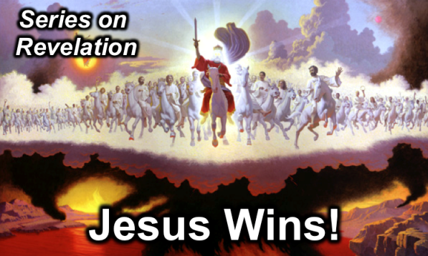
Rick Griffith
16 February 2014
Message 11 of 20

The Christ of Balance
Revelation 6–7

Introduction

We appreciate balance in life.

What’s the right view of Jesus in terms of justice and grace?

Revelation 4–5 shows us that only Christ is worthy to break the seals. But why should he break these seals?

I. Christ will ______________ the world (Rev. 6).

(6:1-2) Christ will open the first seal (white horse) that allows the Antichrist to conquer the world to show Christ's sovereignty over him.

(6:3-4) The second seal (red horse) brings war to depict how Antichrist controls the world as political leader (cf. Matt. 24:6-7a).

(6:5-6) The third seal (black horse) allows Antichrist to use famine to control commodity prices to show his global economic control (cf. Matt. 24:7b).

(6:7-8) The fourth seal (pale horse) affirms that death will come to over one billion people by war, famine, plague, or roaming wild beasts (cf. Matt. 24:9).

(6:9-11) The fifth seal depicts God's reassurance of martyrs in heaven that He alone is sovereign and they should trust in His plan.

(6:12-17) The sixth seal reveals that men will fear a glimpse of Sovereign God more than an earthquake leveling mountains and the opening of the sky (cf. Matt. 24:7c)!

II. Christ will ______________ the believers (Rev. 7).

(7:1-8) The sealing of 144,000 Jews (12,000 from each tribe) will show God's mercy on Israel even during the Tribulation.

(7:9-17) The salvation of Gentiles from every nation indicates God’s merciful fulfillment of the Great Commission during the Tribulation.

Conclusion

Christ balances his ______________ with his ______________ (Main Idea).

Do you have a defective view of Christ?

Do you recognize his right to judge his creation—and even you?

Have you responded to his salvation offer?

Thought Questions:

- Read Revelation 6 aloud, then list what each of these six seals is and what it tell us about Christ.

Seal Judgment | Revelation of Jesus Christ (cf. 1:1)
Seal 1
Seal 2
Seal 3
Seal 4
Seal 5
Seal 6

- Now read chapter 7 aloud. How does it balance out the view of Jesus in chapter 6?

- Do you need to better grasp Jesus as your Judge (Rev. 6) or Savior (Rev. 7)? How?

Walter A. Elwell, Evangelical Commentary on the Bible (Grand Rapids: Baker, 1996), 1209-10; William Hendriksen, More Than Conquerors (Grand Rapids: Baker, 1944), 94-96; Zane C. Hodges, “The First Horseman of the Apocalypse,” Bibliotheca Sacra 19 (Oct 1962): 324-34.
For details on the above points, see Daniel K. K. Wong, “The First Horseman of Revelation 6,” Bibliotheca Sacra 153 (April-June 1996): 212-26.
Walvoord, BKC, 949.
Warren W. Wiersbe, The Bible Exposition Commentary (Wheaton: Victor Books, 1996, c1989), on Rev. 7:1-17.
Walter A. Elwell, Evangelical Commentary on the Bible (Grand Rapids: Baker, 1996), 1209-10; William Hendriksen, More Than Conquerors (Grand Rapids: Baker, 1944), 94-96; Zane C. Hodges, “The First Horseman of the Apocalypse,” Bibliotheca Sacra 19 (Oct 1962): 324-34.
For details on the above points, see Daniel K. K. Wong, “The First Horseman of Revelation 6,” Bibliotheca Sacra 153 (April-June 1996): 212-26.
Walvoord, BKC, 949.
Warren W. Wiersbe, The Bible Exposition Commentary (Wheaton: Victor Books, 1996, c1989), on Rev. 7:1-17.
Walvoord, BKC, 949.

